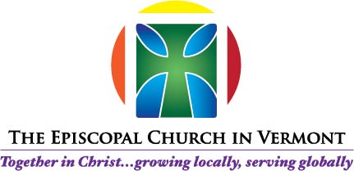

RACIAL RECONCILIATION CLERGY DAY

Phase I: “Acknowledgement”

Trinity Episcopal Church, Rutland

October 10, 2017

10:00 AM to 3:00 PM

AGENDA

Opening Prayer

Guidelines for Effective Cross-Cultural Dialog

Introductions: Name & Location

Activity I: Icebreaker

Activity II: The Acknowledgement Spectrum

Small Group Discussions

Lunch

Presenter: The Rev. Dr. Arnold Thomas  
*Pastor, Good Shepherd Lutheran Church  
Jericho, VT*

Presenter: Ms. Shela Linton  
*Co-founder, The Root Social Justice Center  
Brattleboro, VT*

Q&A with Presenters

Break

Small Group Discussions

Plenary Session  
*Sharing Our Intentions  
Furthering Our Acknowledgement*

Bishop’s Closing Remarks

Guidelines%20for%20Effective%20Cross%20Cultural%20Dialogue%20-%20Visions,%20Inc.pdf