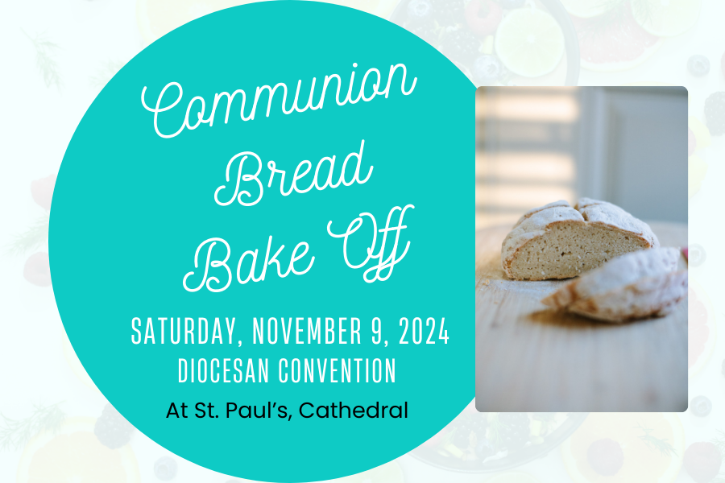

Thank you for your interest in the Communion Bread Bake Off!

Your bread must be:

Gluten Free
Delicious
Not Crumbly

Please make 2 6-8 in. loaves.
Please provide ingredient list.
Provide the name of your parish.
Provide your name.
Bring it with you to St. Paul’s Cathedral on November 9.

Winning Bread recipe will be published in a future Mountain and recipe will be used to make Communion Bread for the 2025 Diocesan Convention.

